**DEPLOYING APPLICATION IN MICROSERVICES**

**step1:**

Name: wordpress-1

AMI: Ubuntu (latest version)

Instance Type: t2.micro

Key Pair: Create or select an existing key pair (for SSH access)

Security Group:HTTP, HTTPS, SSH, MySQL(Only from the MySQL instance private IP),tcp

**Step-2:**

Name: mysql-1

Instance Type: t2.micro

Security Group: Separate security group for MySQL(Allow inbound from WordPress Private IP)

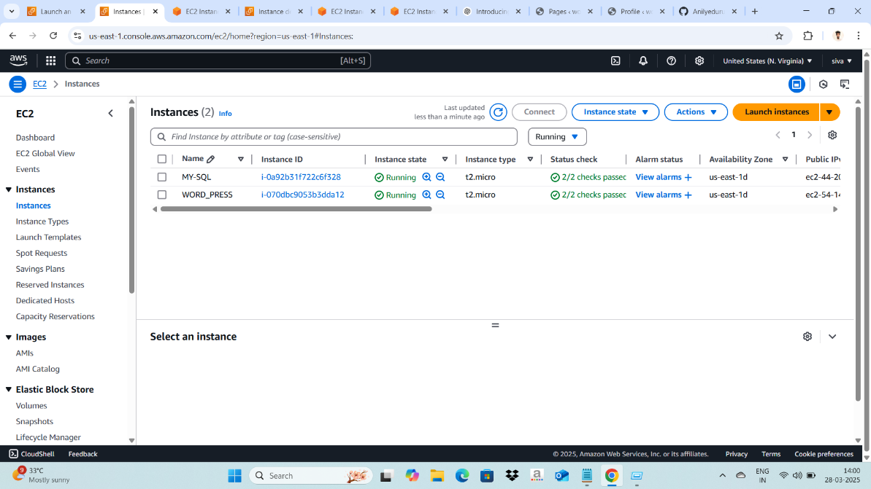

Step 3:Install and Configure MySQL on MySQL Instance

3.1: Connect to MySQL EC2 Instance:

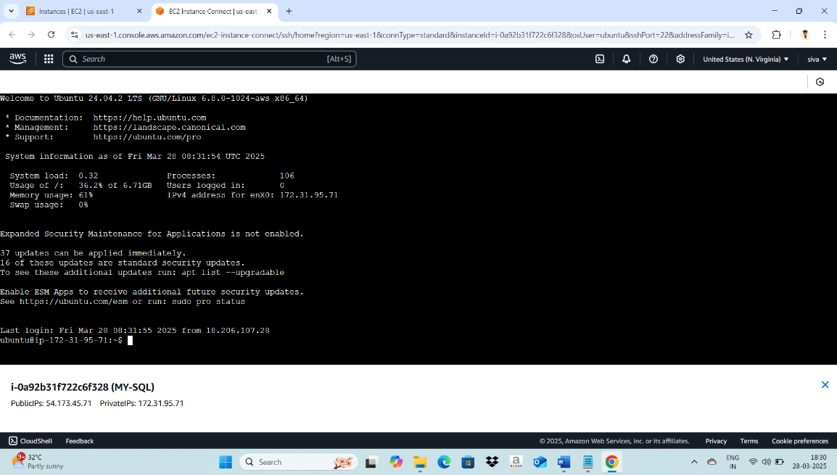

🡪3.2: Install MySQL Server:

sudo apt update

sudo apt install mysql-server -y

🡪3.3. Secure MySQL Installation

sudo mysql_secure_installation

* Set root password

* Remove anonymous users

*Disable remote root login

*Remove test database

🡪3.4. Create WordPress Database & User

sudo mysql -u root -p

Inside MySQL shell, run:

CREATE DATABASE wordpress_db;

CREATE USER 'wp_user'@'%' IDENTIFIED BY 'Bunny@8866';

GRANT ALL PRIVILEGES ON wordpress_db.* TO 'wp_user'@'%';

FLUSH PRIVILEGES;

EXIT;

🡪3.5. Allow Remote Connections: (Edit the MySQL config:)

sudo nano /etc/mysql/mysql.conf.d/mysqld.cnf

Find the line:

bind-address = 127.0.0.1

Change to: bind-address = 0.0.0.0

Restart MySQL:

sudo systemctl restart mysql

Installation and Configure Wordpress on EC2

4.1: Connect to Wordpress EC2 Instance:

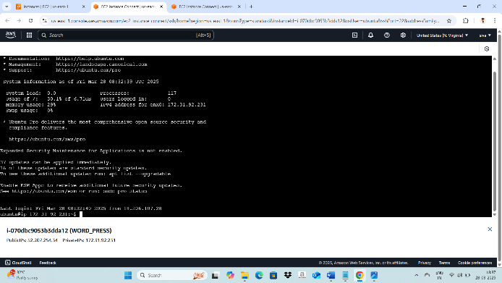

4.2. Install Apache, PHP, and Dependencies

sudo apt update

sudo apt install apache2 php php-mysql libapache2- mod-php unzip -y

4.3. Download and Extract WordPress

cd /var/www/html

sudo wget https://wordpress.org/latest.zip

sudo unzip latest.zip

sudo mv wordpress/* .

sudo rm -rf wordpress latest.zip

4.4. Configure WordPress Database Connection

sudo cp wp-config-sample.php wp-config.php

sudo nano wp-config.php

Modify these lines with your database info:

define('DB_NAME', 'wordpress_db');

define('DB_USER', 'wp_user');

define('DB_PASSWORD', 'mypassword');

define('DB_HOST', 'your-mysql-instance-private-ip');

4.5. Set Permissions

sudo chown -R www-data:www-data /var/www/html

sudo chmod -R 755 /var/www/html

4.6 Restart Apache

Sudo systemctl restart apache2

……………………………………………………………………………..

Step 5: Access WordPress & Create Welcome Page

1. <http://your-wordpress-instance-public-ip>

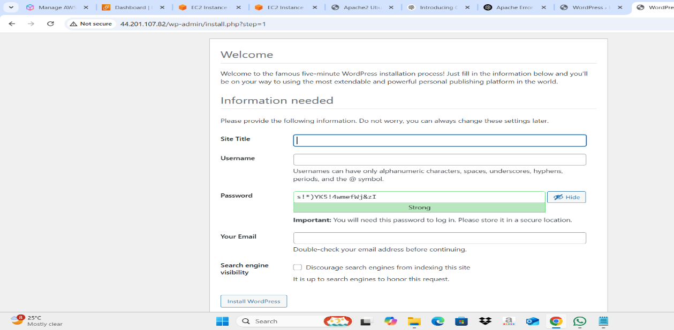

1. Complete Instalation

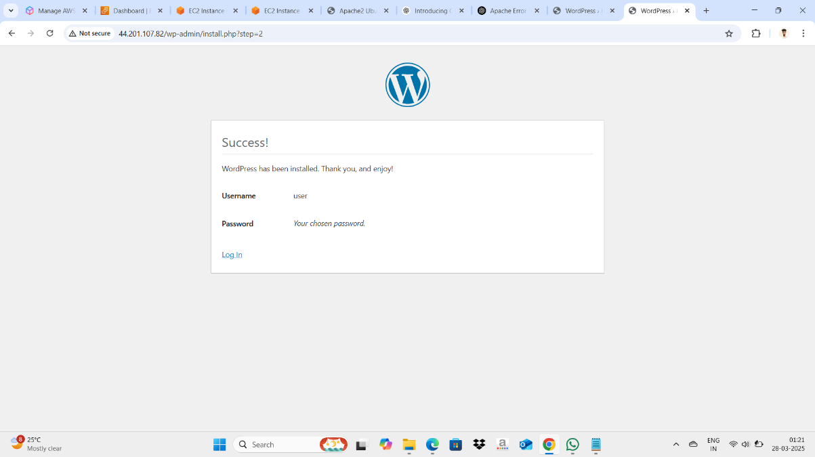

log into Wordpress page:

Add a New Page & add your own content:

After Publish

Copy your publish URL & paste in new webserver page and check your published content accessing or not:

<http://54.197.173.37/index.php/welcome-to-microservices/>

